* Welcome Home Page:

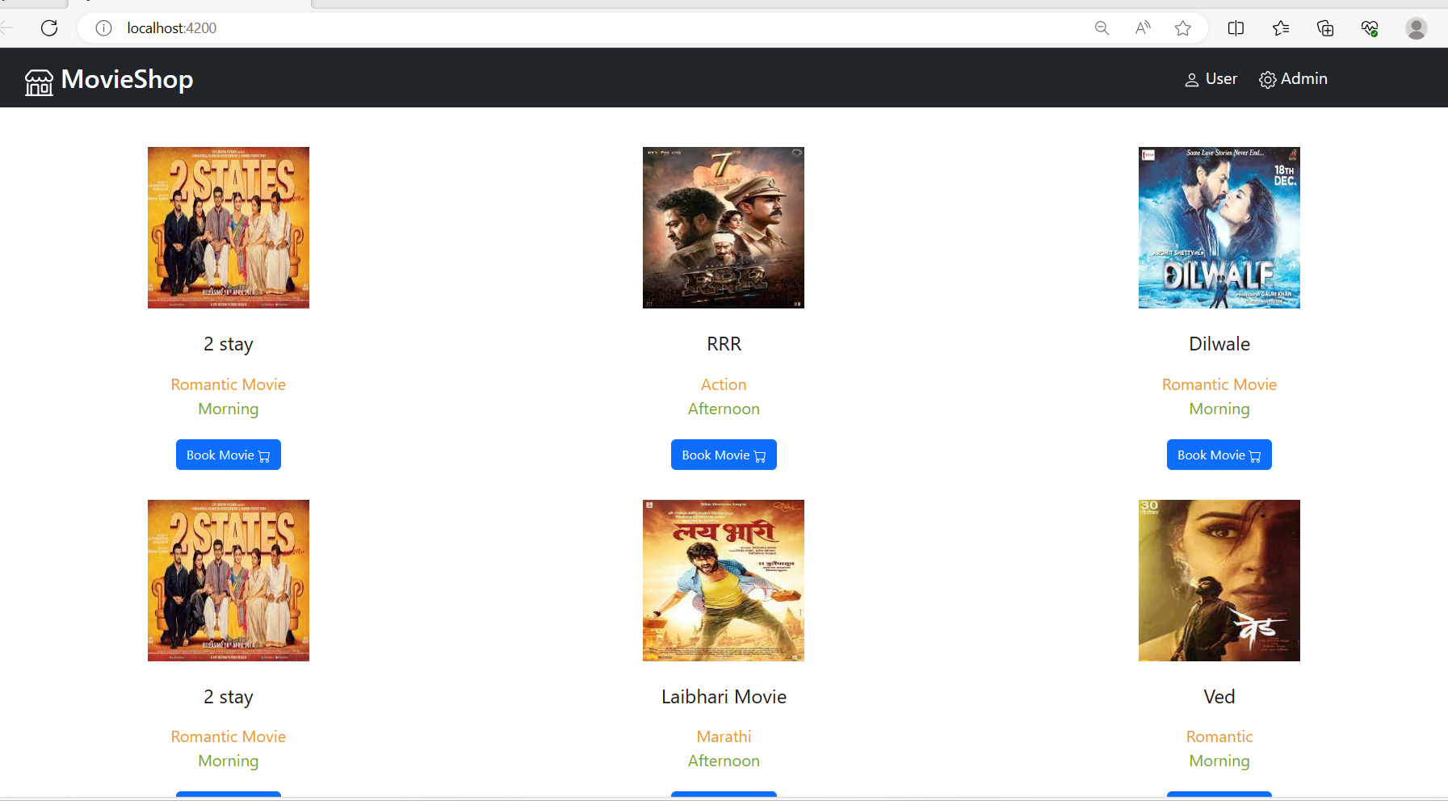

* **Admin Interface:**

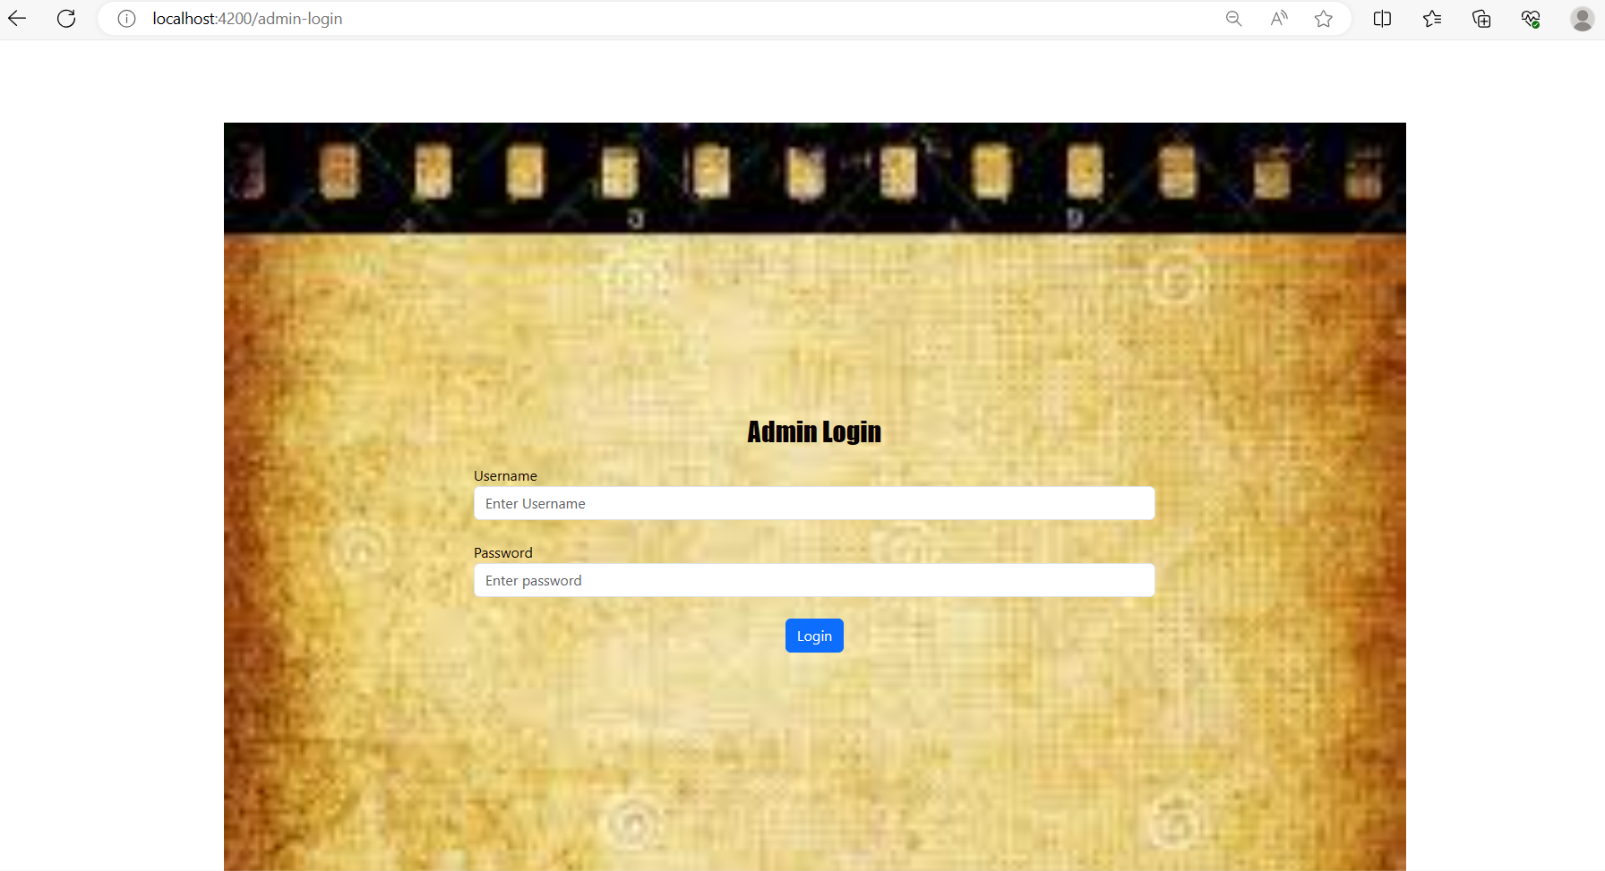

* Admin Authentication:

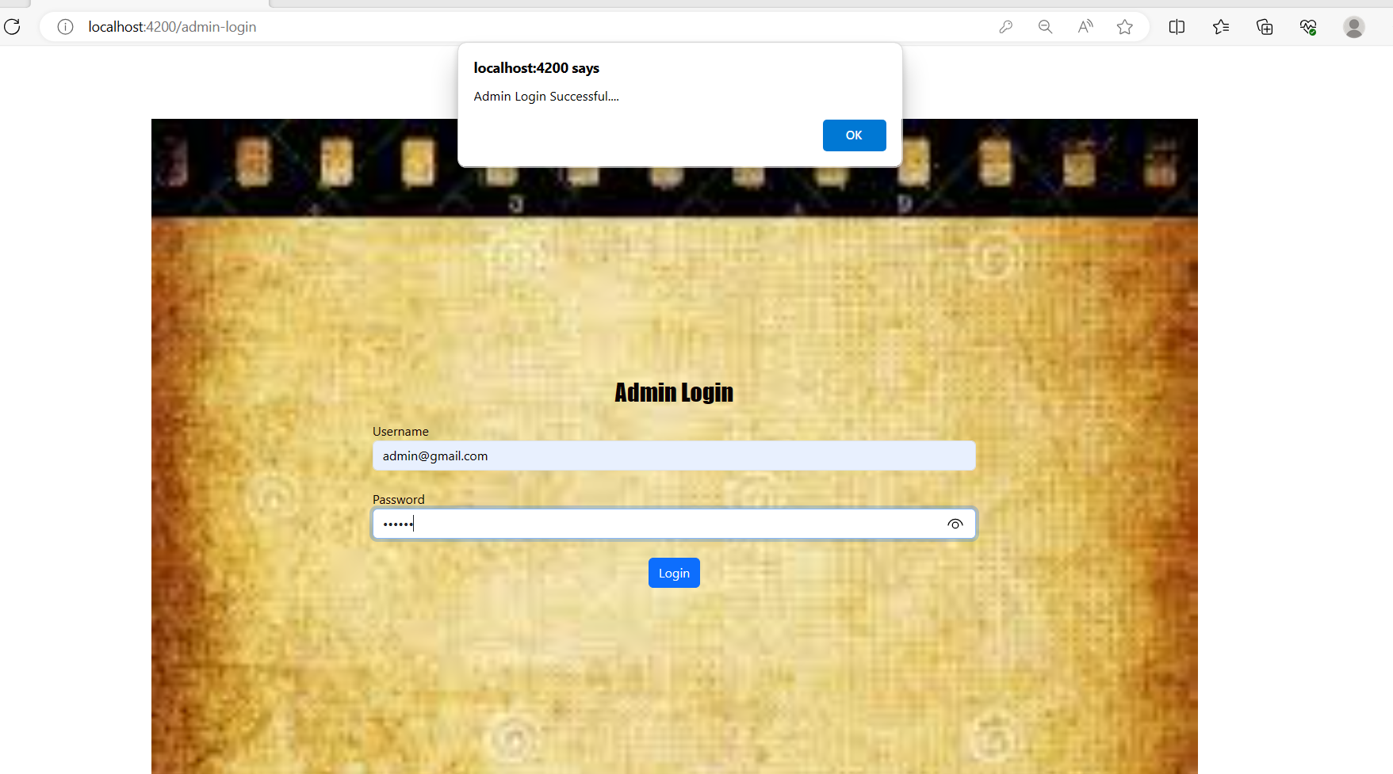

* Once Admin Login Successfully application provide you admin Operation:

Such as Movies, Tickets, Shows and logout

First option with List of movies with add new movie button

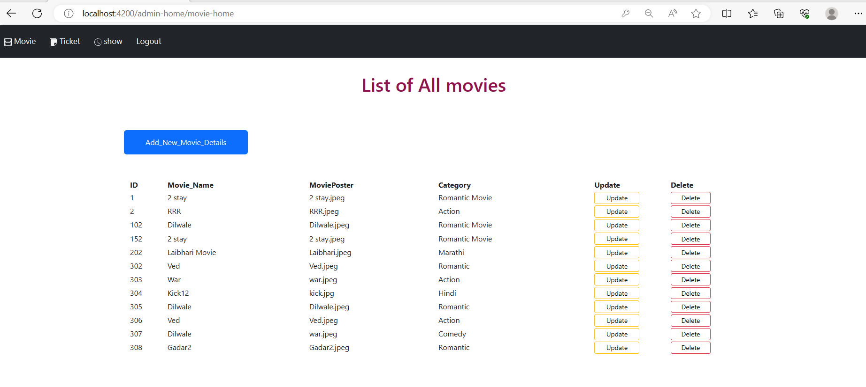

* Add new movie button allow admin to add new Movies in the portal:

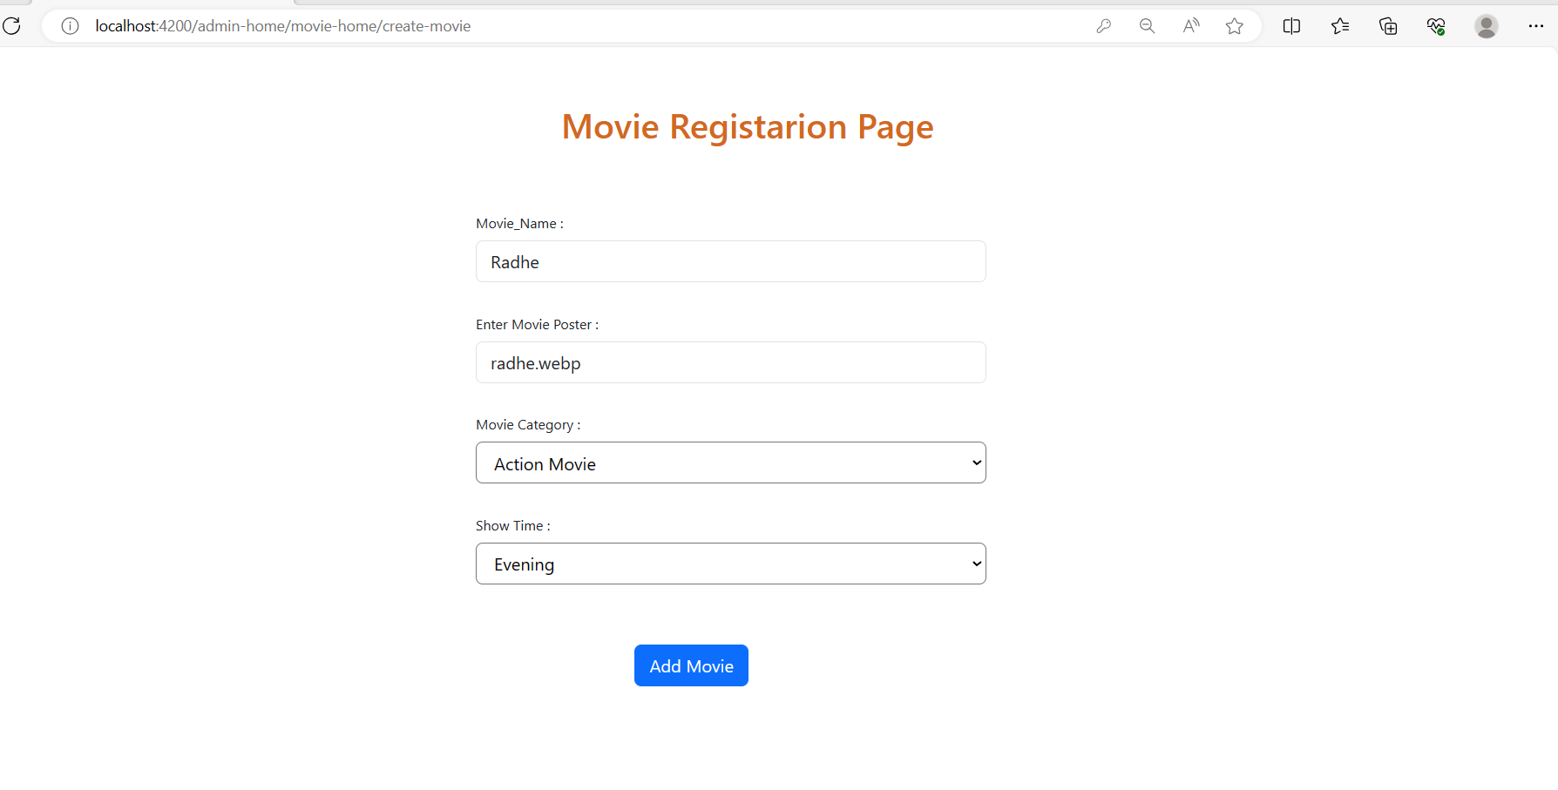

* After clicked on add movie the register movie successfully added in list of movies and available on the portal:

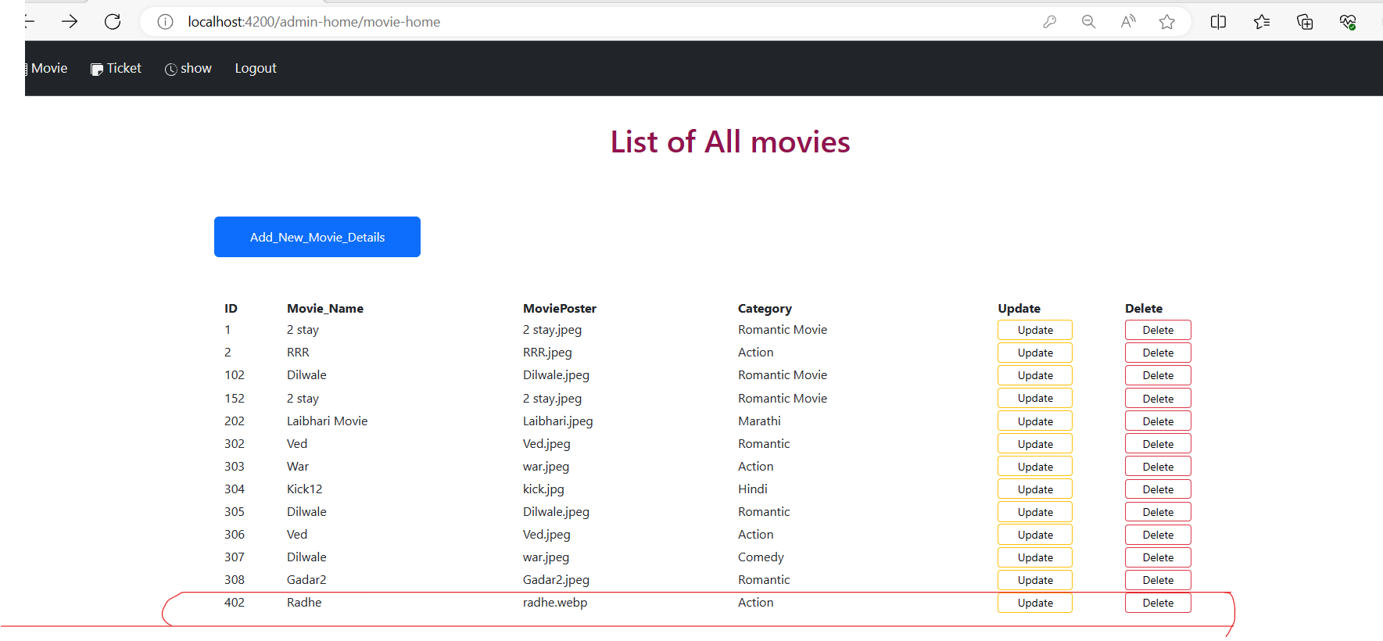

* Update movie Option allow admin to update in movies details like time name category etc :

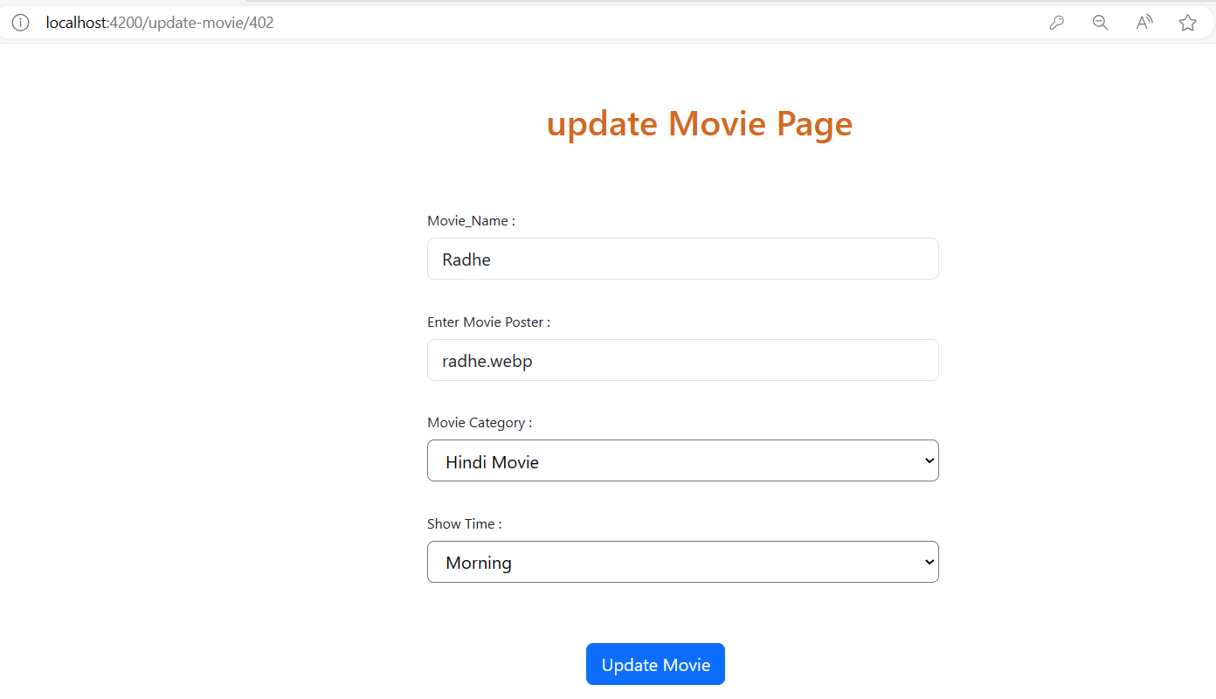

* Once clicked on update movie details are reflected on movie list page:

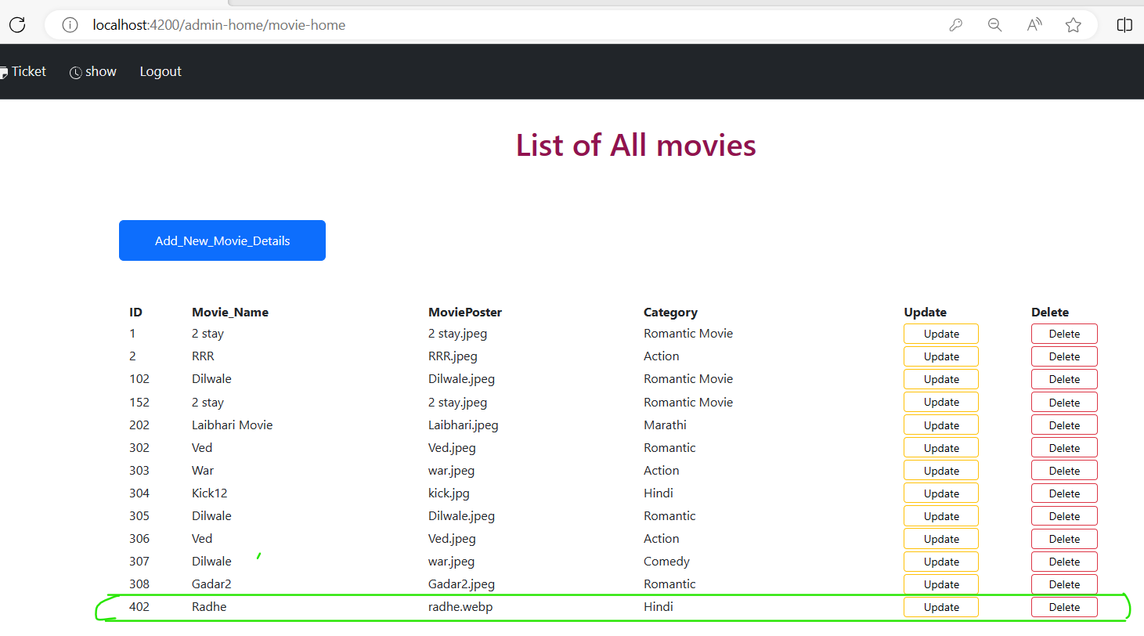

* If admin want to deleted any movie, admin can do it using delete button. let’s delete the movie id 302

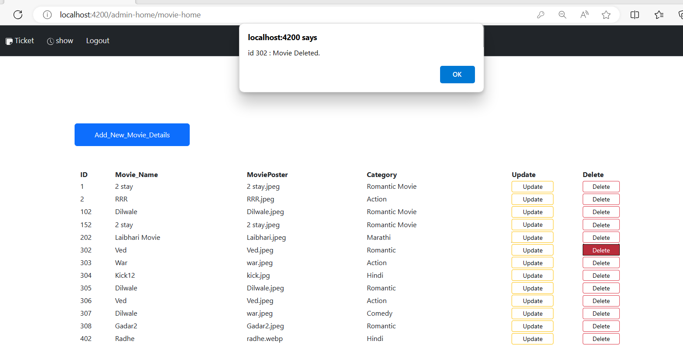

* Let’s go to Next operation of admin Ticket details: 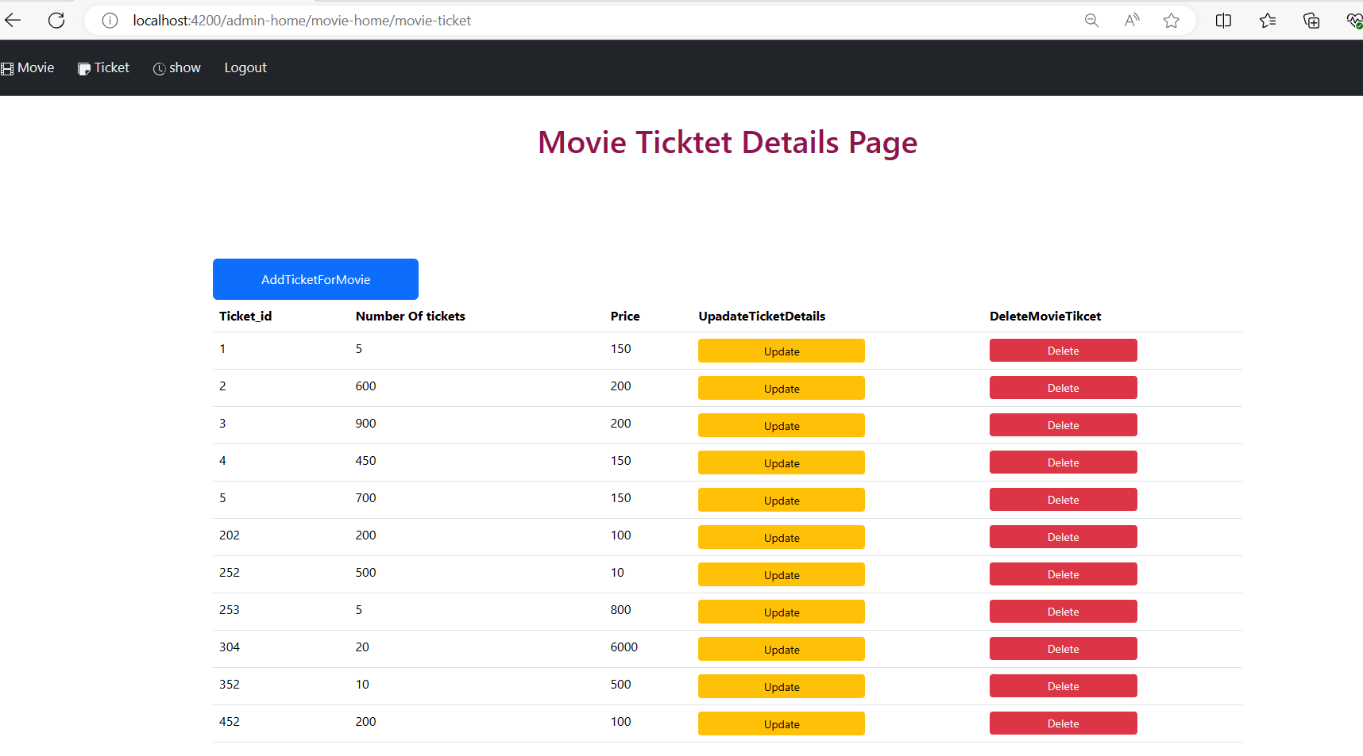
* Here as well admin can add, update and delete the tickets .

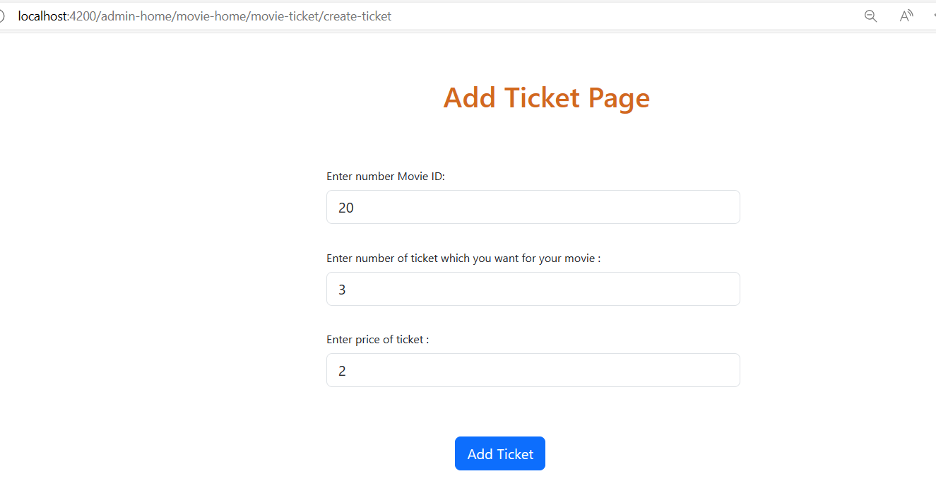

* Update ticket Details:

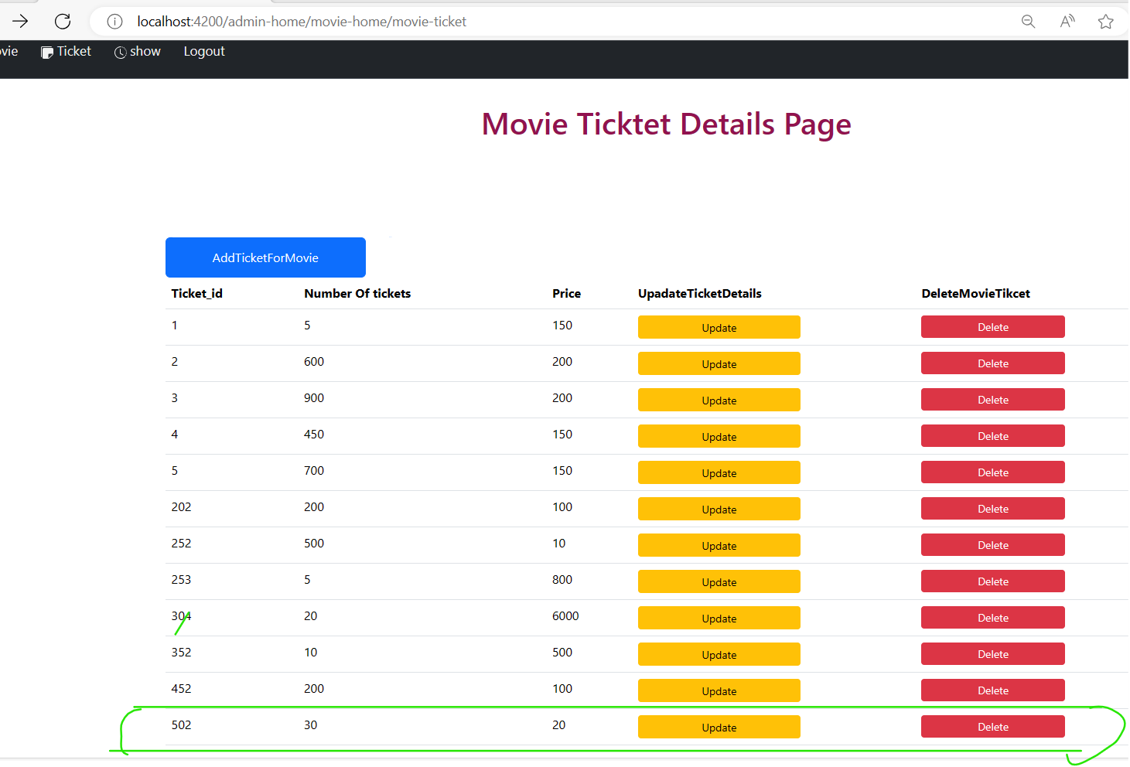

* Now deleting the same ticket.

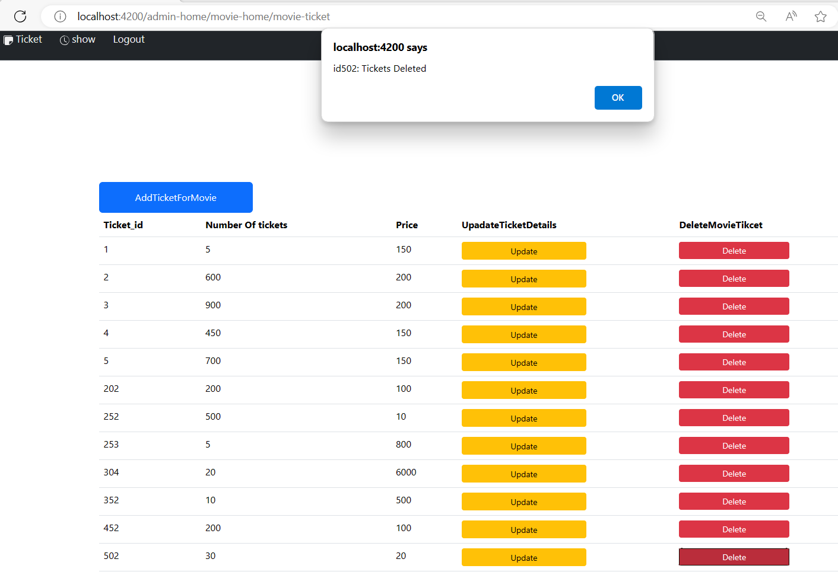

* Next option List of show time admin can add using this option:

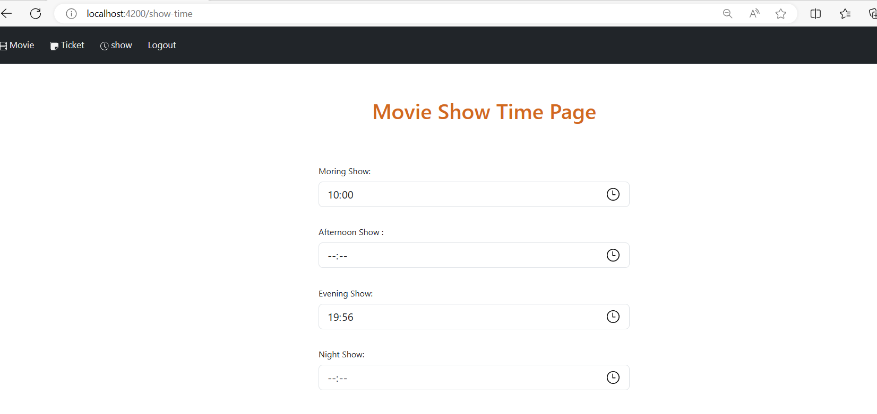

* Last operation for admin is logoff. one admin clicked on logoff button it redirects to welcome home page.

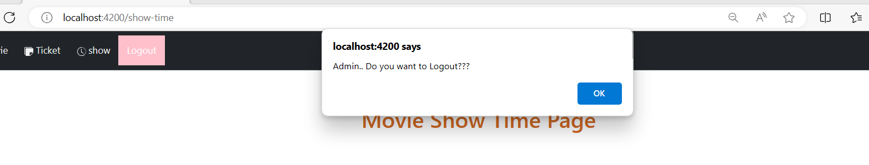

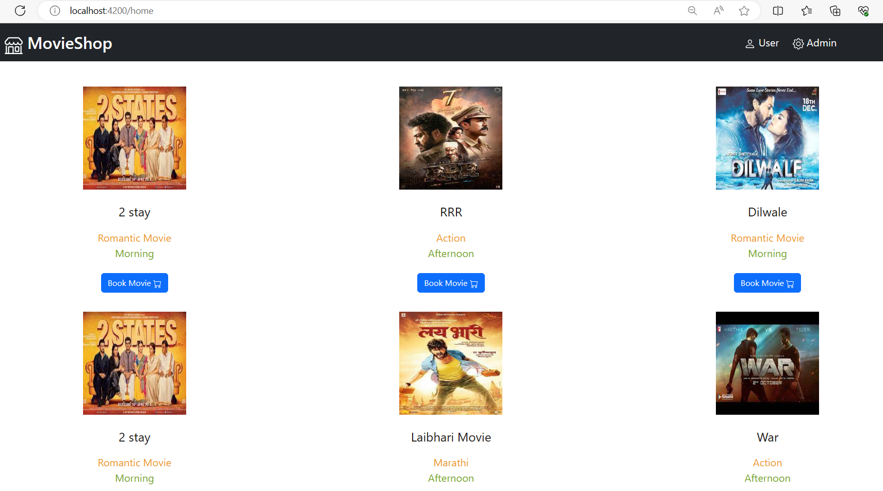

* **User Interface:**
* if user try to book movie portal ask him, please login first:

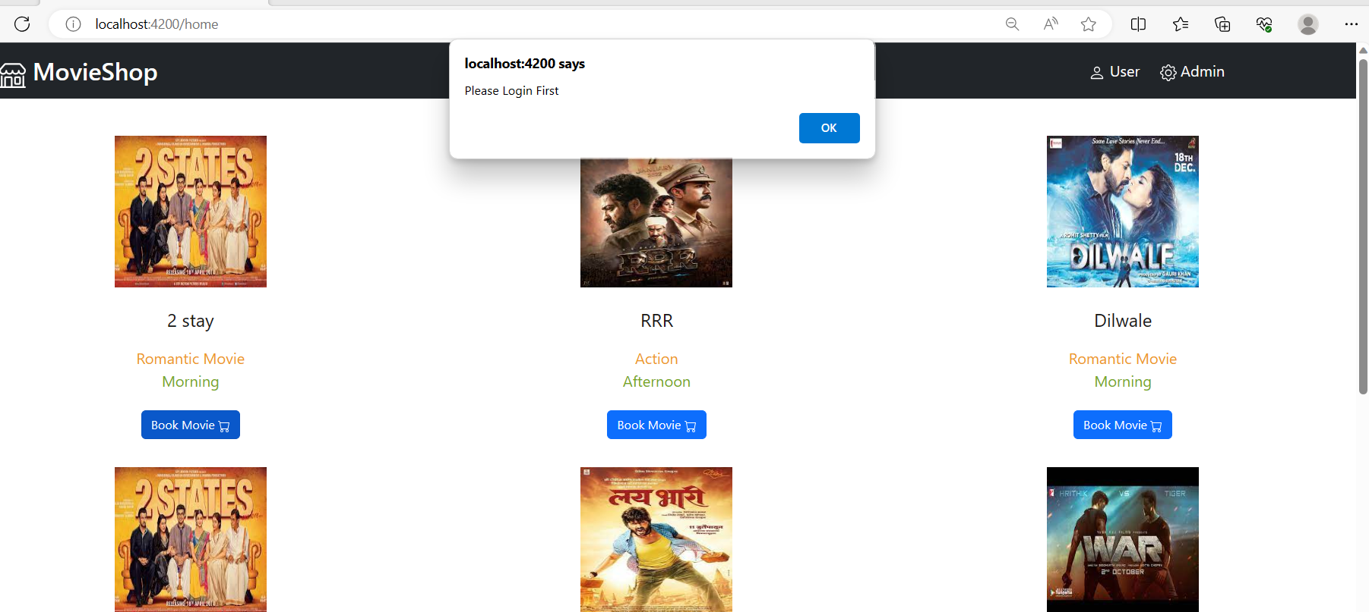

* Go to user Option and try to login, if you are new user please register first and with your credential try to login.

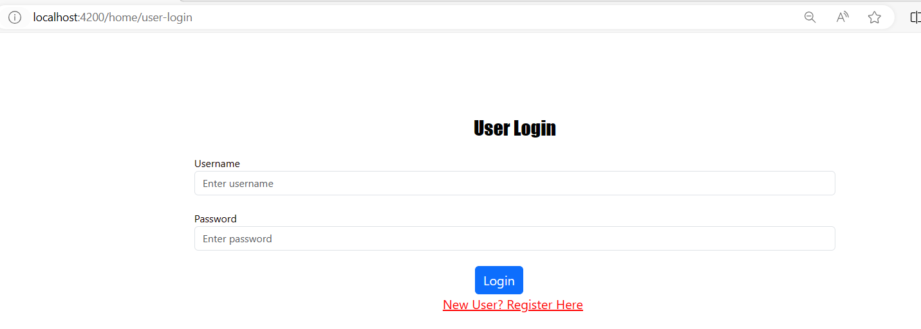

* Let’s Register first:

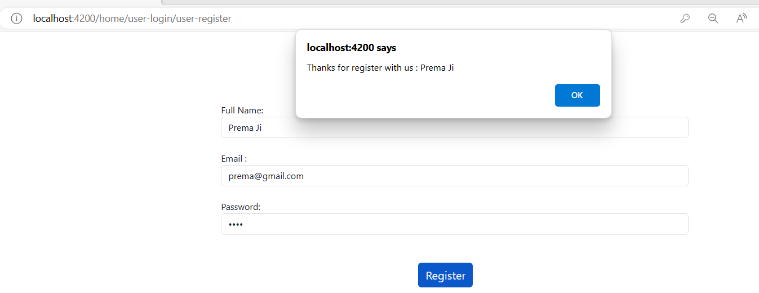

* Now try to login with this credential:

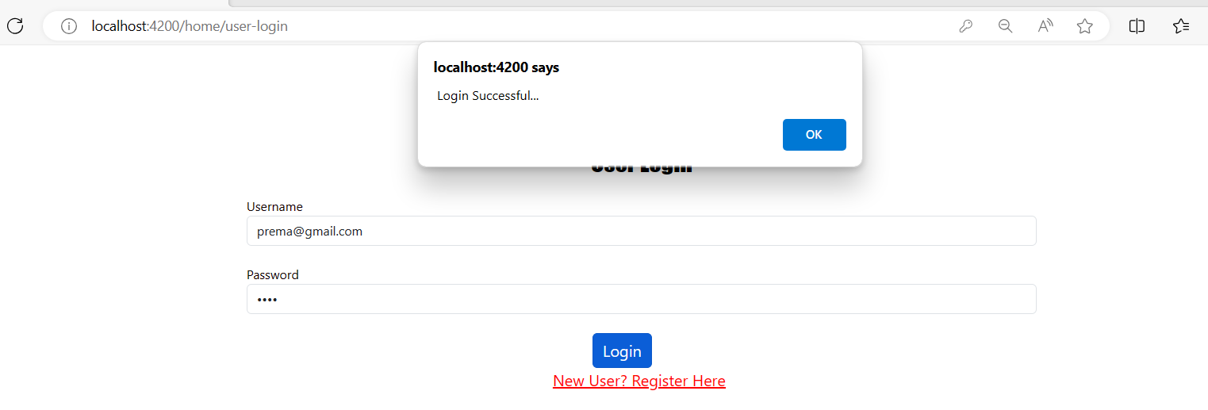

* After Successfully registration, portal redirect you to booking page.

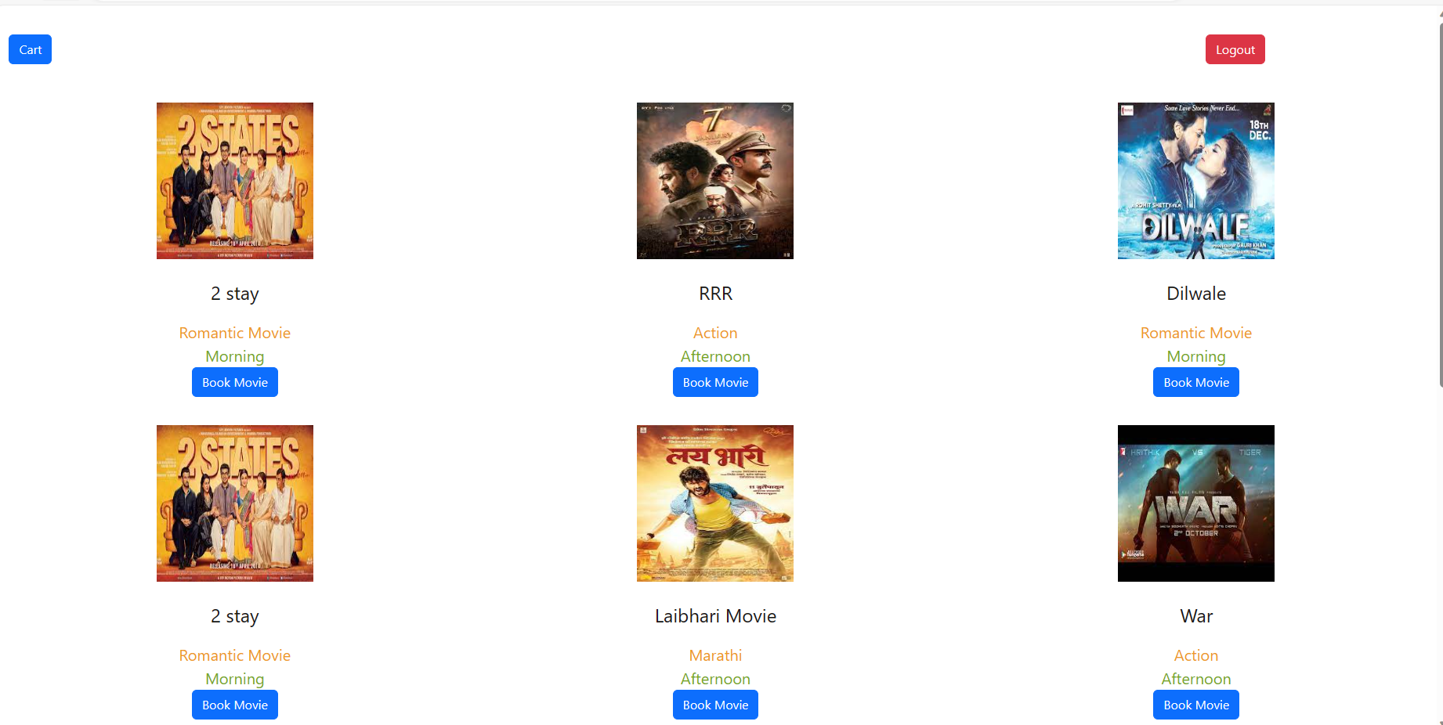

* Now User can book any movie and that movie tickets into the cart, as well user can logoff from this page by clicked on logout button.

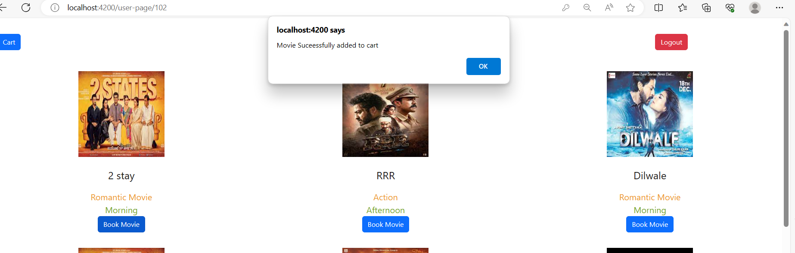

* Cart Page Show all details related to Movie and Ticket to be book:

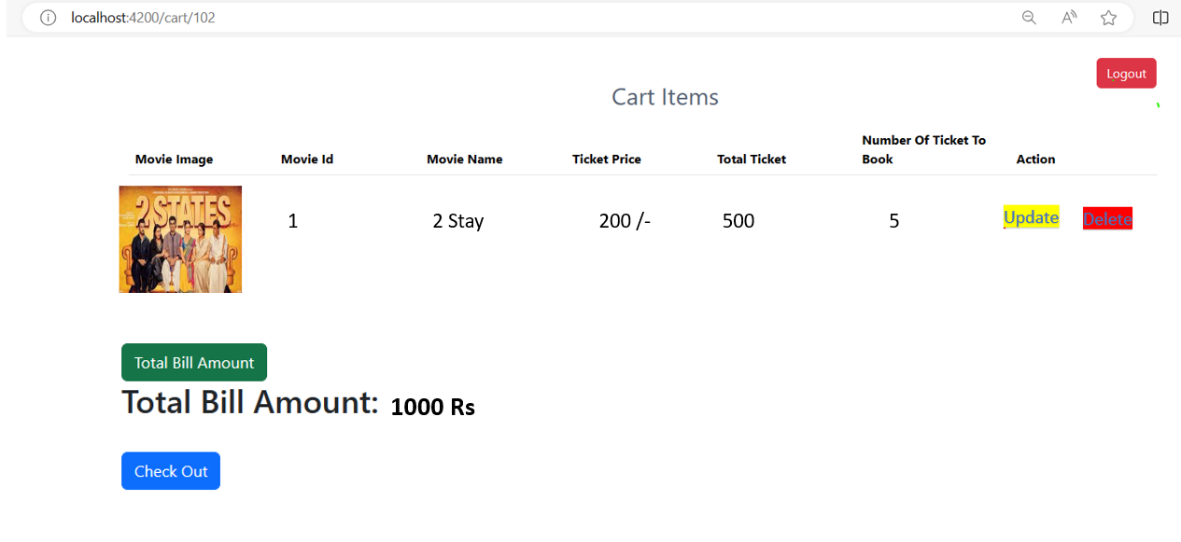

* Once Clicked on check out Button portal redirect to payment page:

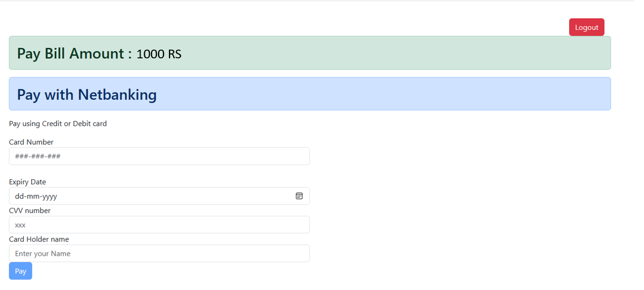

* Once User clicked on Pay button Movie Ticket Booking Successful.

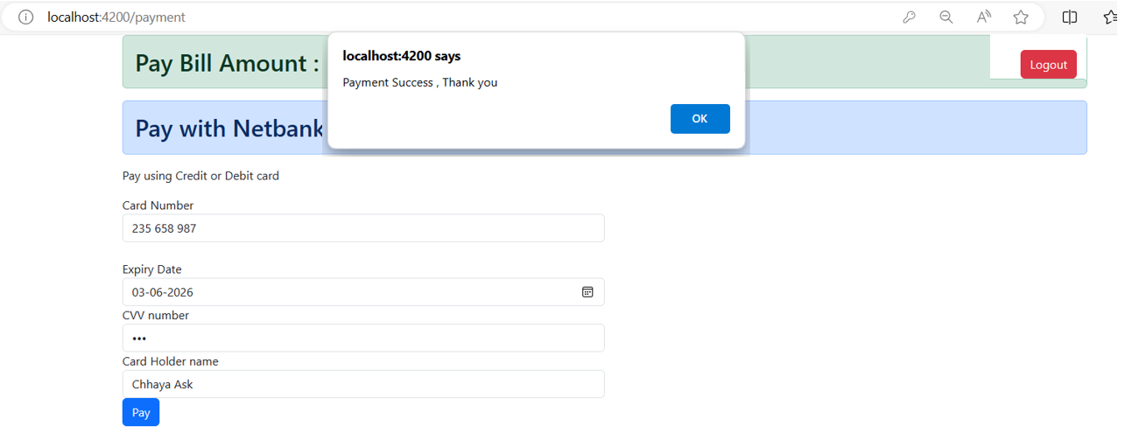

* Back To Welcome Home Page:

